**Quetsion#1**

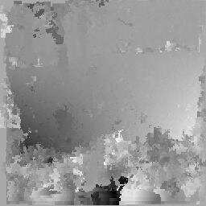**1-**

2- Apply a power law transformation with gamma=0.4:

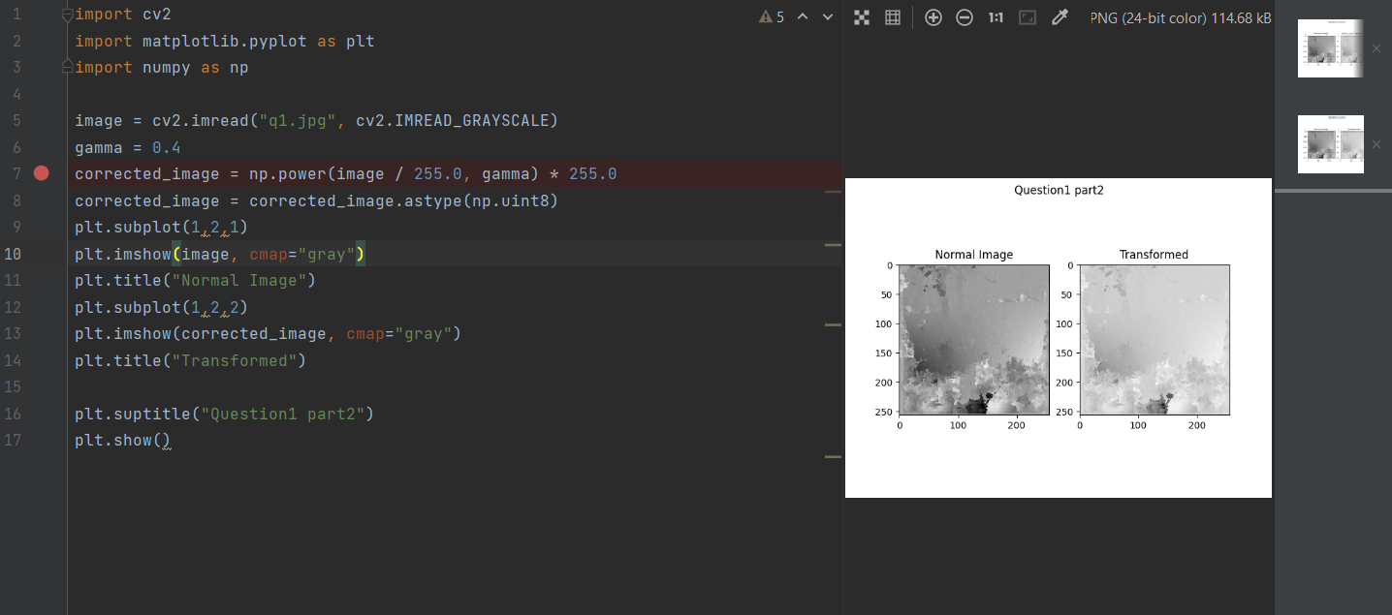

* As we can see in the image, the dark areas have been lightened: since 0.4 is less than 1, thus the effect of lifting the shadows and revealing details in the dark parts of the image that were previously obscured, the dark areas in the transformed image are significantly lighter, revealing details that were previously hidden. However, the overall contrast of the image is also reduced, and the sky appears slightly less bright.

3- Add a zero-mean Gaussian noise (with variance =40 gray-levels) to the original image

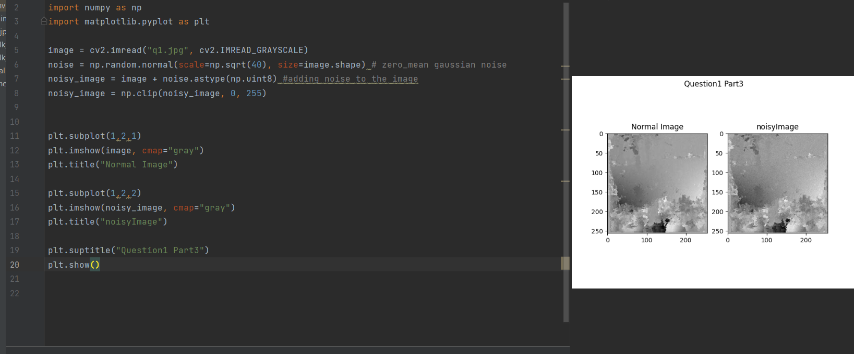

* As we can see the noise adds a significant amount of grain to the image, obscuring the smooth gradient and reducing the overall clarity, adding noise can also have undesirable consequences, such as reducing the accuracy of image processing algorithms.

4-Apply a 5 by 5 mean filter to the noisy-image you obtained in point 3 above

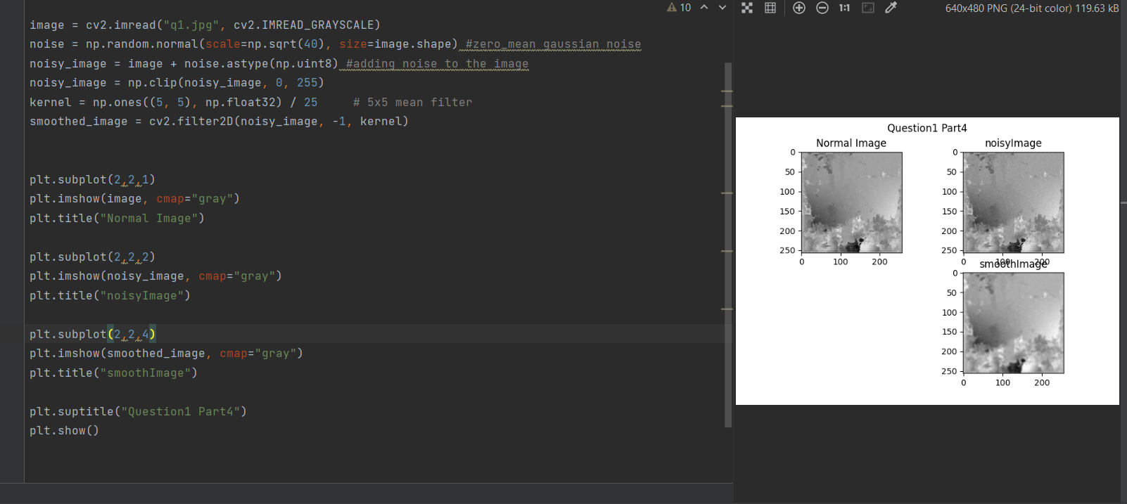

* As we can see, the combination of noise addition and mean filtering has both positive and negative impacts on the image. While the noise is effectively reduced, it comes at the cost of some image sharpness and detail loss.

5-Add salt and pepper noise (noise-density=0.1) to the original image and then apply a 7 by 7 median filter to the noisy-image and show both images.

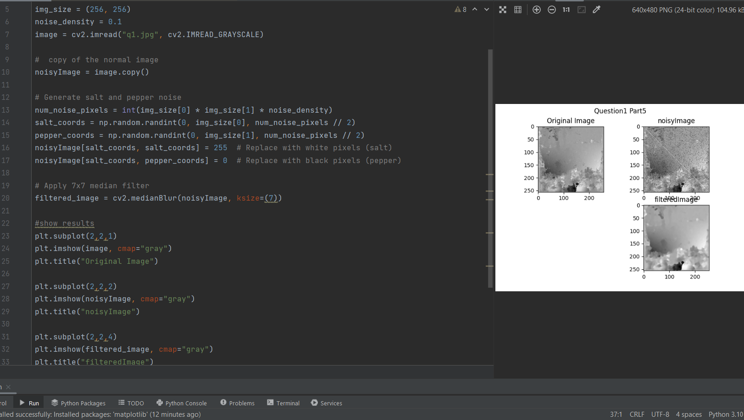

* As we can see after applying a 7x7 Median Filter the image is noticeably smoother, with the black and white noise points mostly gone. However, some finer details around the windows and edges might be slightly softened compared to the original , the combination of salt and pepper noise addition and median filtering has a clear impact on the visual appearance and information content of the image. While the noise is effectively removed, some details might be sacrificed in the process.

6-Apply a 7 by 7 mean filter to the salt and pepper noisy-image and show the result. Discuss the results in your report:

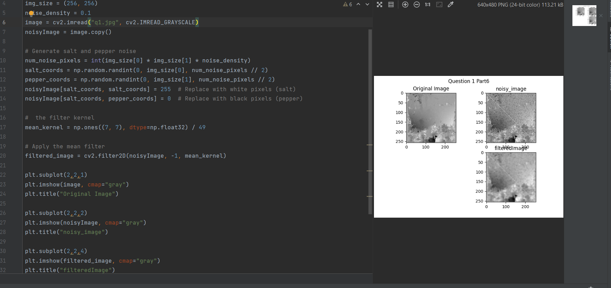

* As you can see, after applying a 7x7 Mean Filter the image is noticeably smoother, with the black and white noise points mostly gone. However, the edges and fur details look softer and less defined compared to the original. Additionally, the overall contrast of the image might appear slightly reduced the combination of salt and pepper noise and a 7x7 mean filter can reduce noise effectively, but at the cost of some image sharpness and detail loss.

7-Apply a Sobel filter to the original image and show the response:

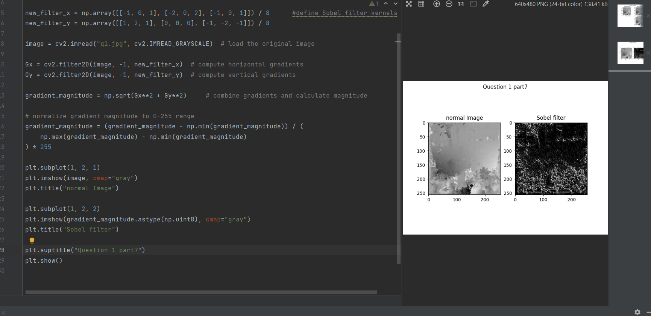

* Applying a Sobel filter to an image to highlight its edges and contours, essentially emphasizing the boundaries between different regions of the image. The combined result generates a magnitude and direction for each pixel, highlighting edges where these values are high.

**Quetsion#2**

**Q2.1**

**Normal && Blurred 3x3**

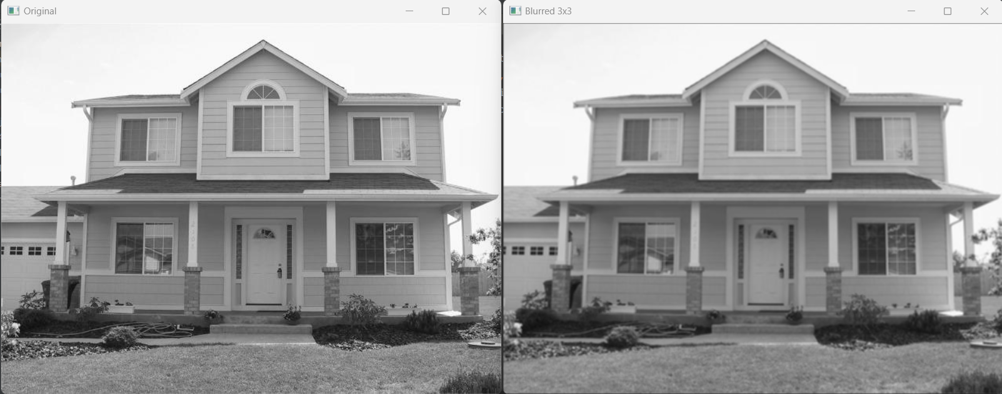

**Blurred 5x5 && Gaussian (σ=1)**

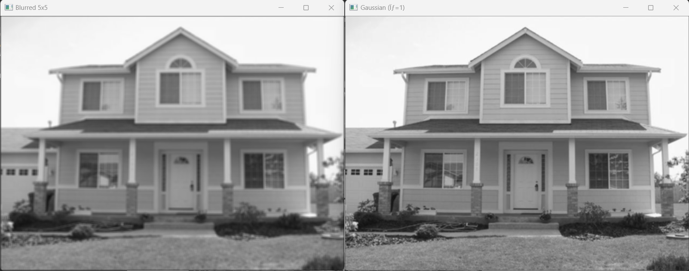

**Gaussian (σ=2) && Gaussian (σ=3)**

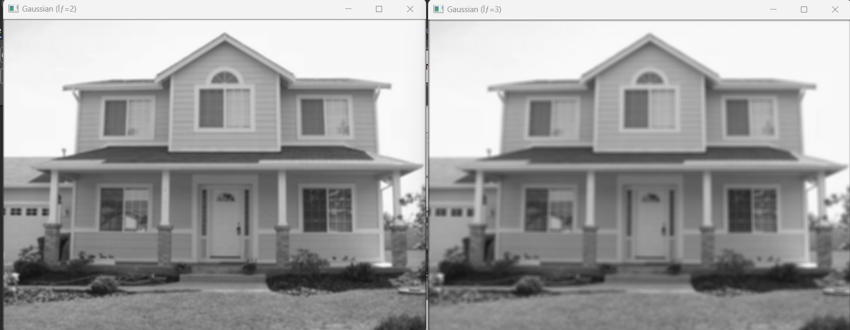

**Sobel Horizontal && Sobel Vertical**

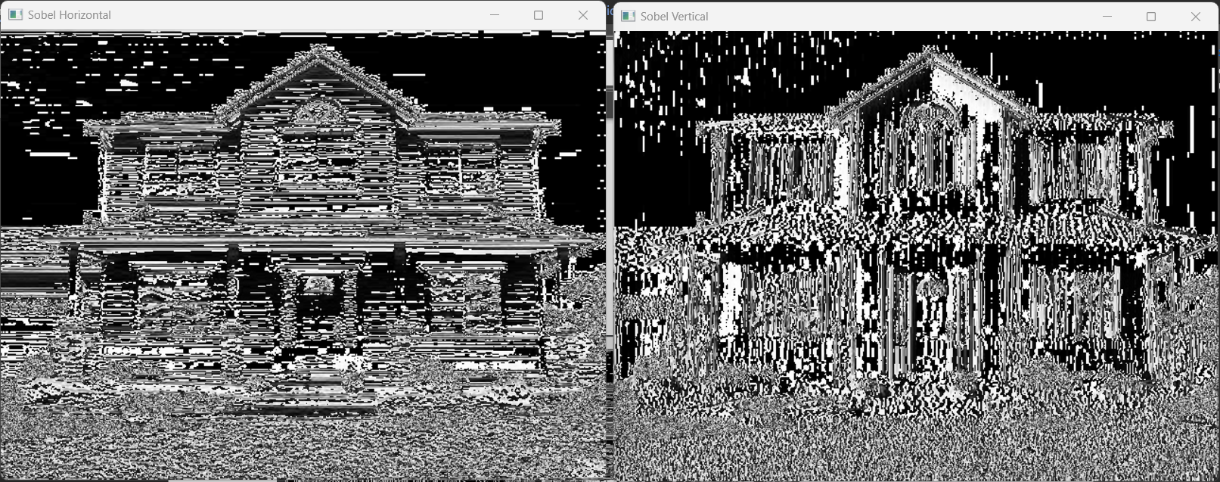

**Prewitt Horizontal && Prewitt Vertical**

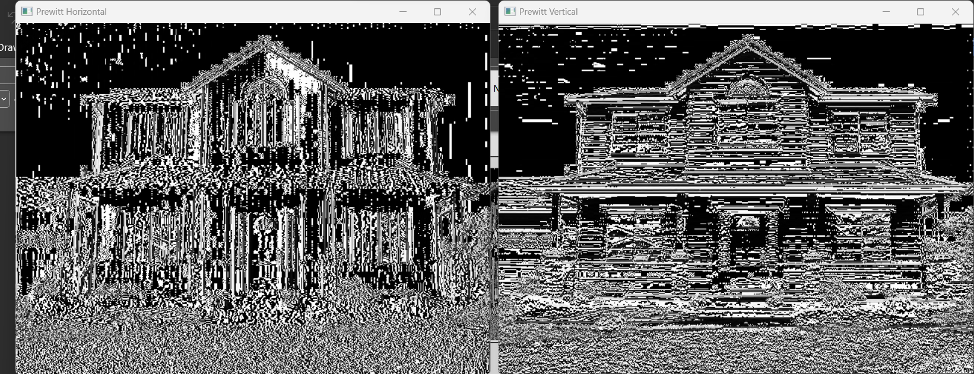

**Q2.2**

**Normal && Blurred 3x3**

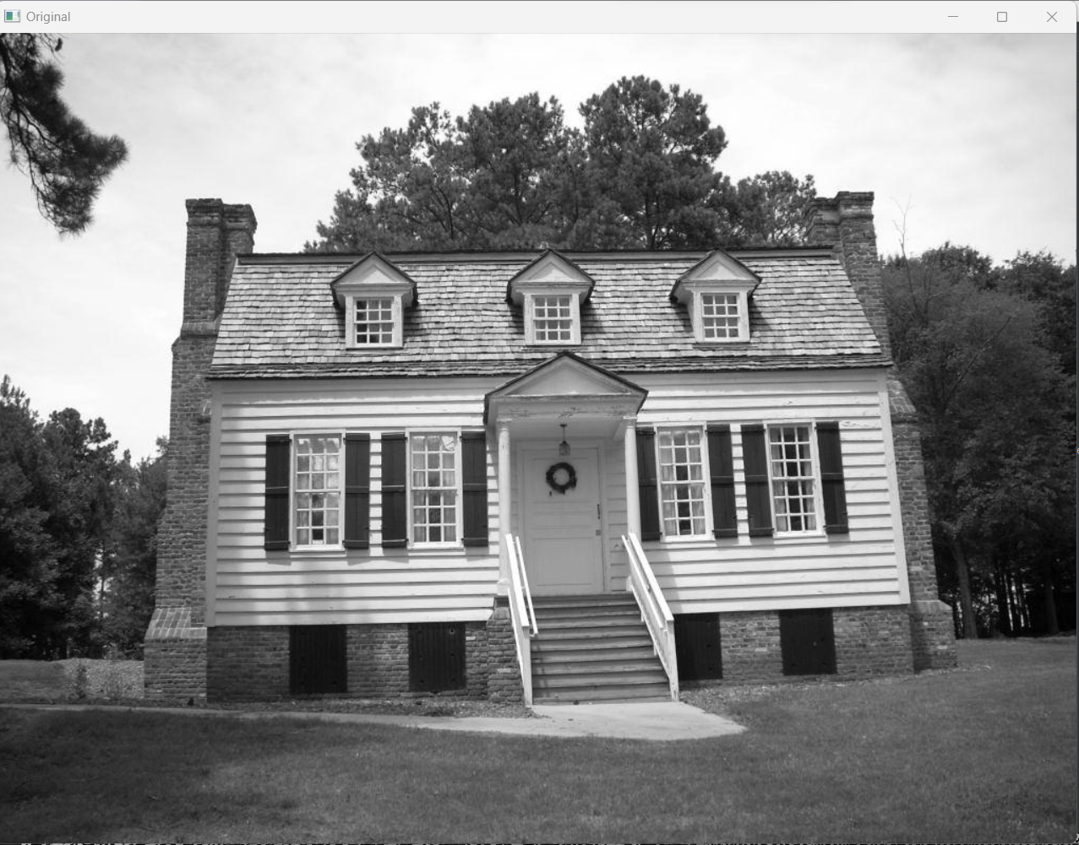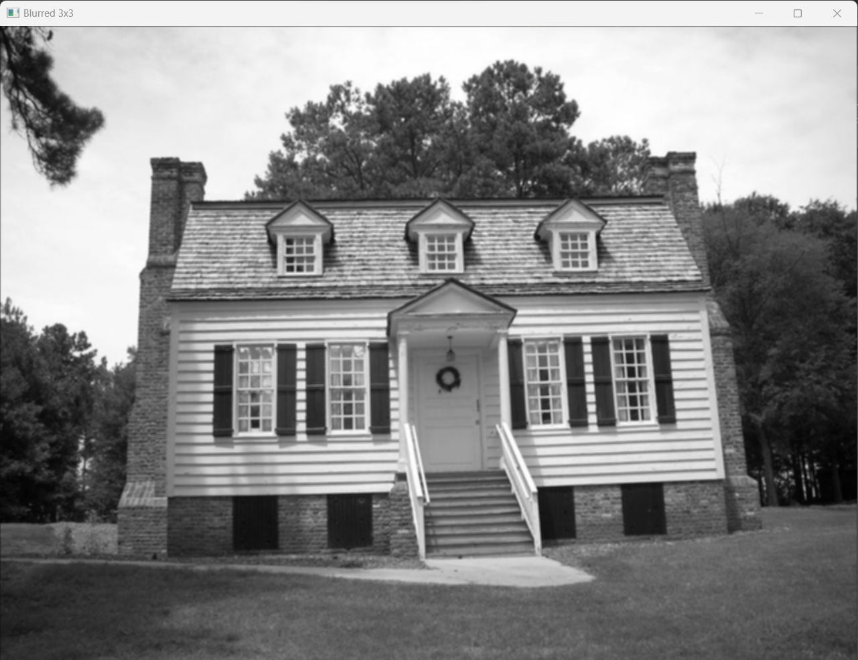

Original: More realistic and detailed look, suitable for tasks requiring precision and clarity.

Blurred 3x3 : Softer and less cluttered appearance, can be used for artistic effects or background smoothing.

**Blurred 5x5 && Gaussian (σ=1)**

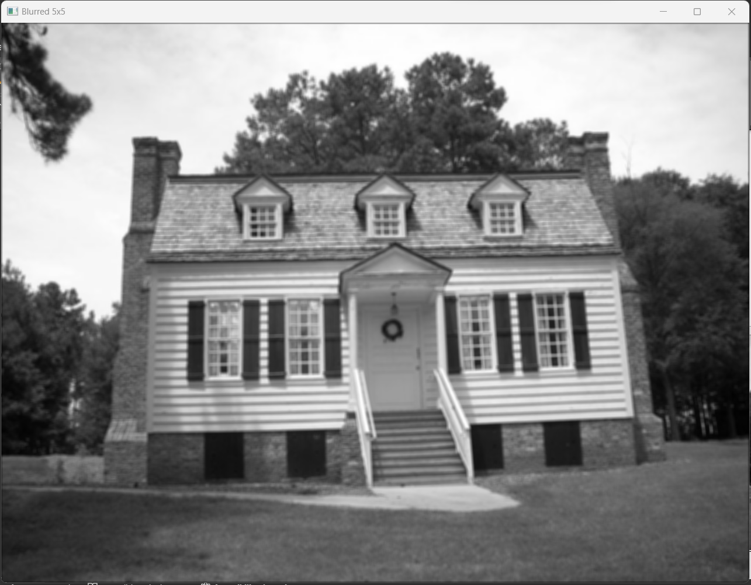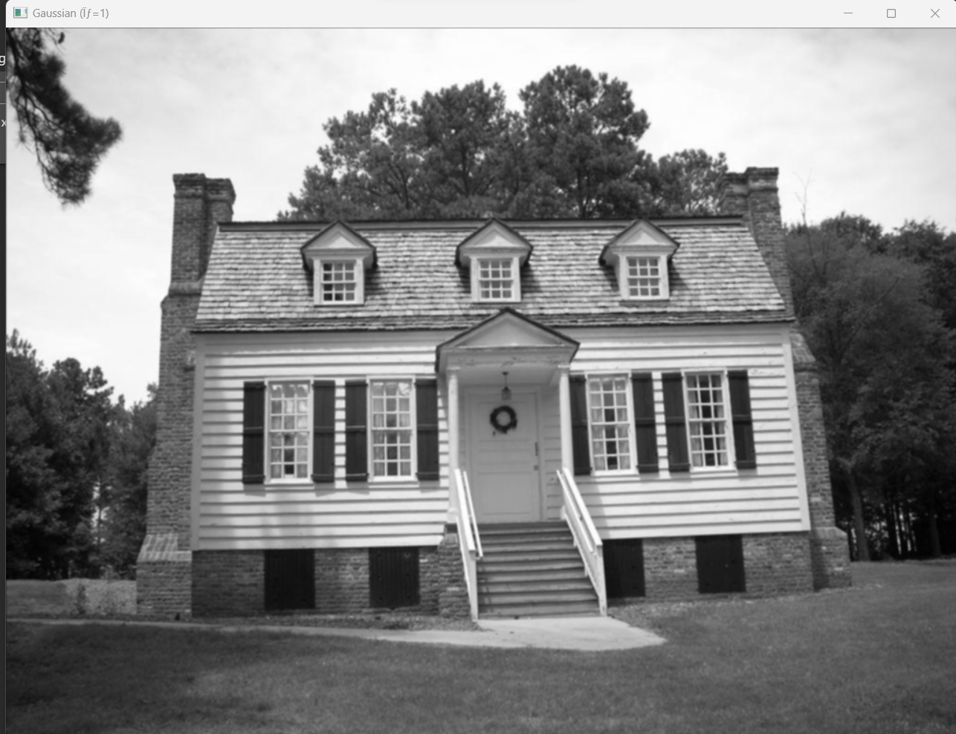

* As we see The 5x5 Averaging Kernel is a filter that induces significant blurring in an image by replacing each pixel , This uniform blurring affects all areas of the image equally, resulting in a "washed-out" appearance and a loss of fine details and textures. On the other hand, Gaussian Kernels offer varying degrees of blurring controlled by the standard deviation (σ). Higher σ values lead to stronger blurring and softer edges.

**Gaussian (σ=2) && Gaussian (σ=3)**

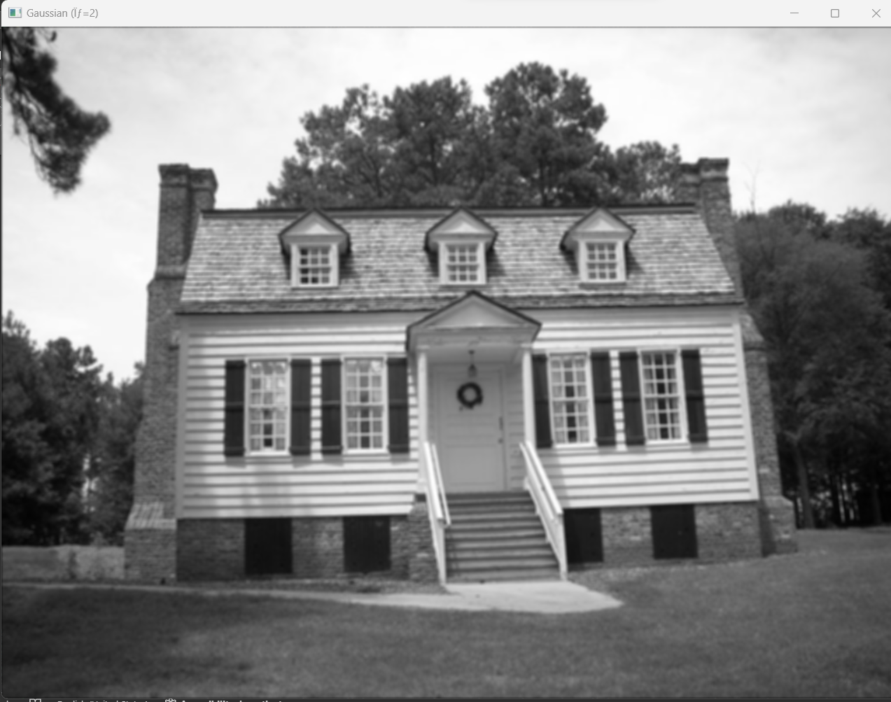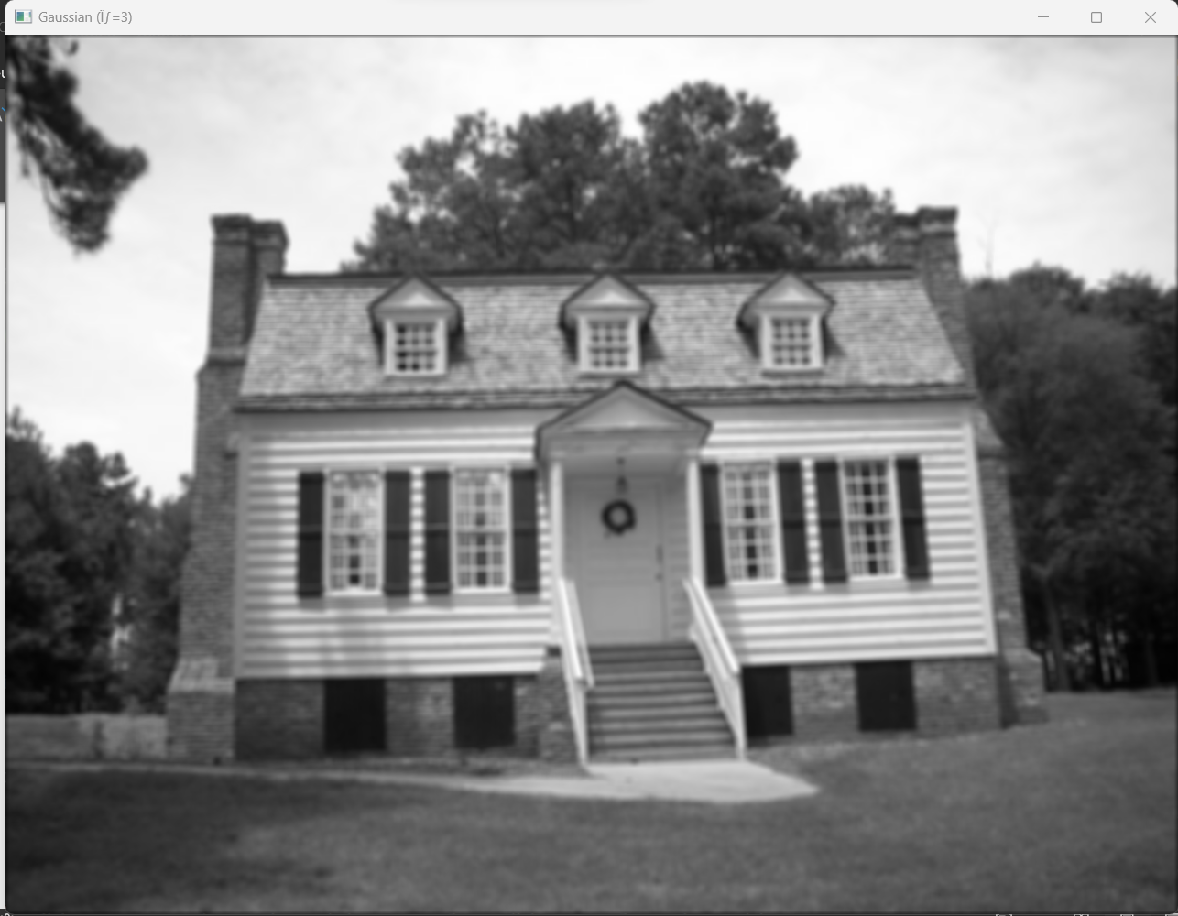

σ=2: The image loses some sharpness but remains largely recognizable. It can be useful for subtle noise reduction or softening harsh backgrounds.

σ=3: The image undergoes a more noticeable change, becoming significantly smoother and losing a lot of detail. This can be used for artistic effects, abstract rendering, or simplifying an image for basic shape recognition.

**Sobel Horizontal && Sobel Vertical**

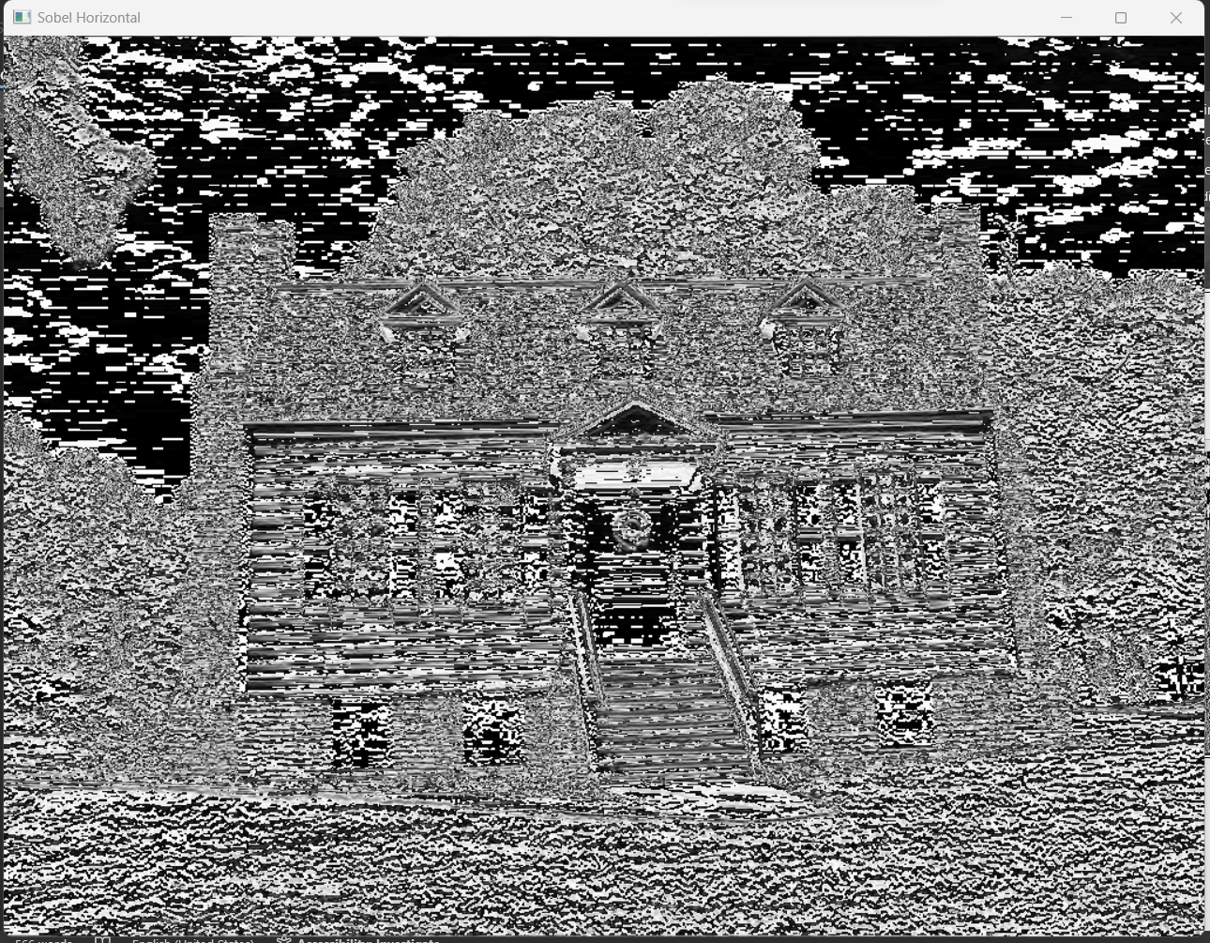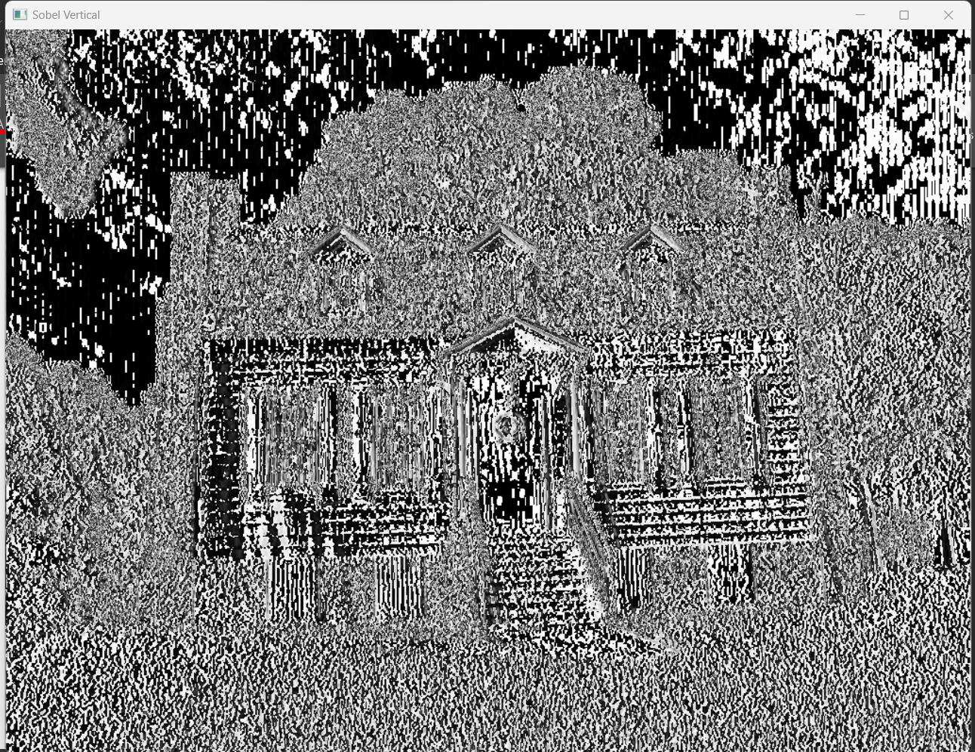

house image with highlighted horizontal edges of the roof, windows ,trees and ground lines

house image with highlighted vertical edges of the roof, windows, trees and ground lines

**Prewitt Horizontal && Prewitt Vertical**

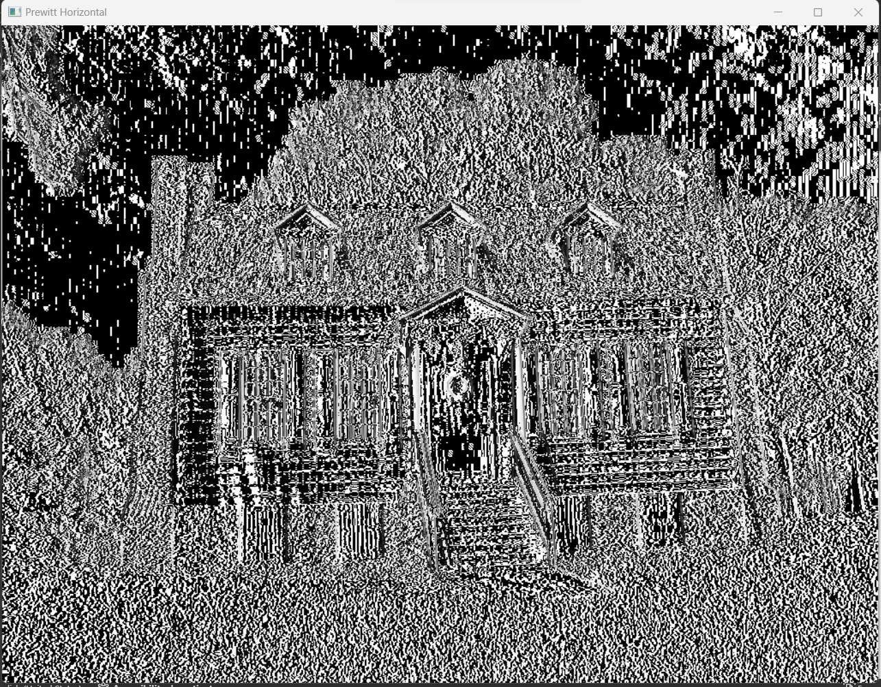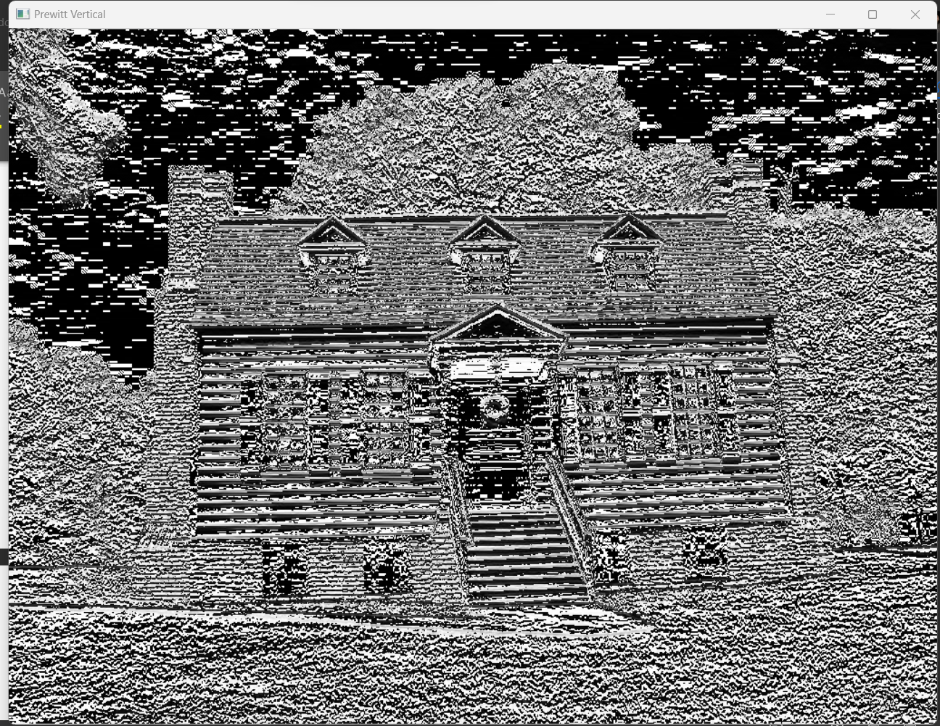

* The house image with enhanced horizontal edges of the roof lines. Vertical features like walls and windows remain clearly visible but softened slightly.
* The house image with accentuated vertical edges of the walls and windows. Horizontal features like the roof and ground are still visible but softened slightly.

**Quetsion#3**

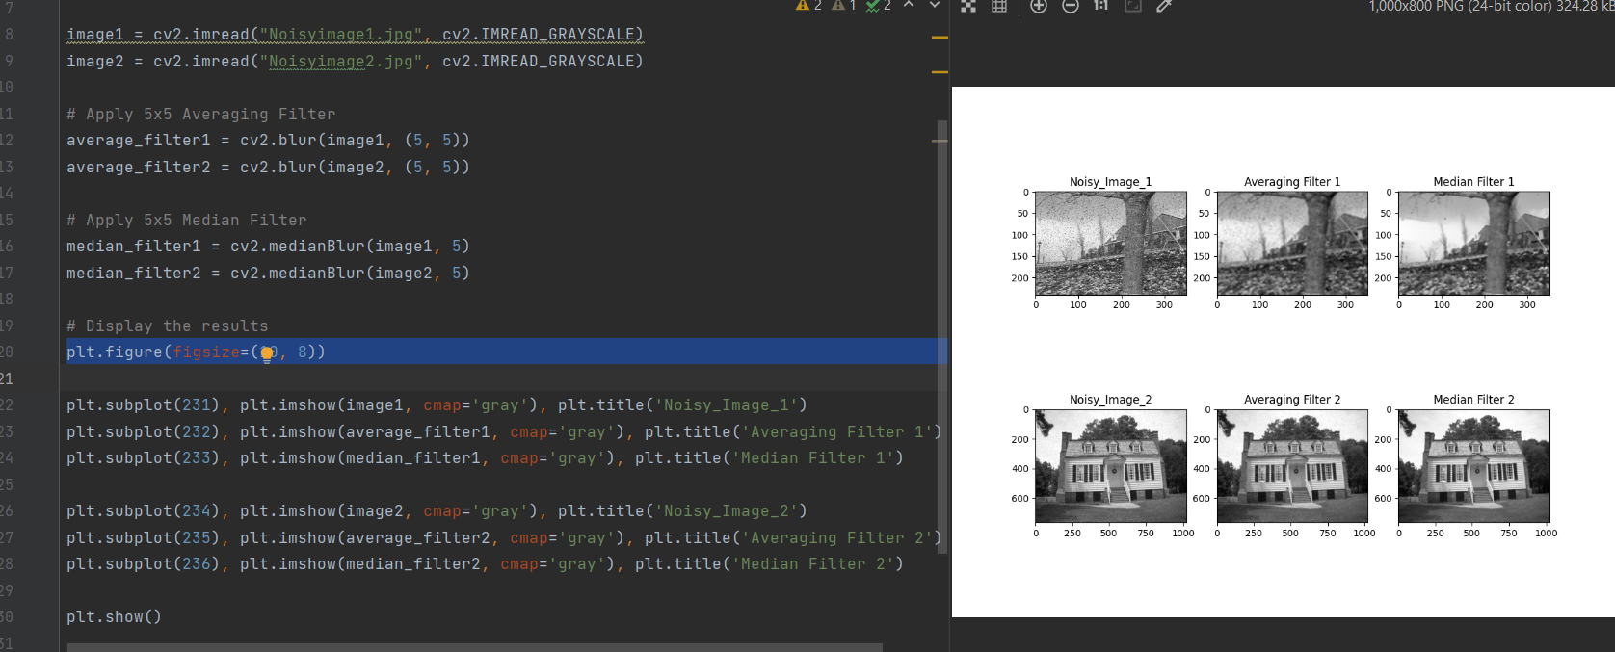

Both the median filter and the averaging filter are used to reduce noise in images and signals, but they work differently and affect the processed data in various ways. Because the median filter may efficiently reduce some types of noise while preserving edges and features, it frequently performs better than the averaging filter in some cases.

**Quetsion#4**

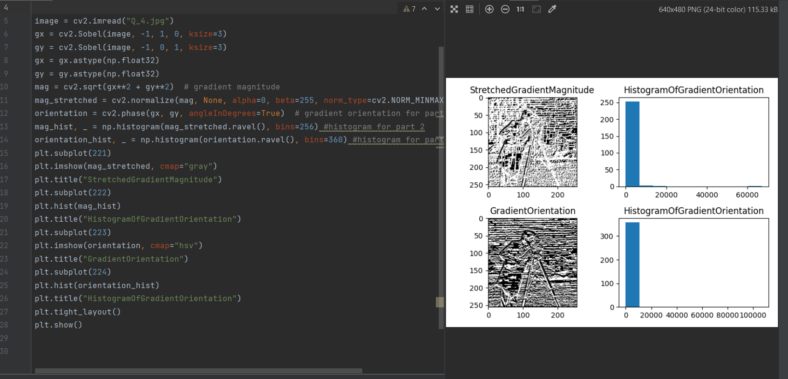

dividing an image into a grid of cells and computing gradient magnitudes and orientations for each pixel within these cells. Histograms are then constructed for each cell, depicting the distribution of gradient orientations. By concatenating these histograms, a comprehensive HOG feature vector is formed, encapsulating information about the structure and shape of objects in the image.

**Quetsion#5**

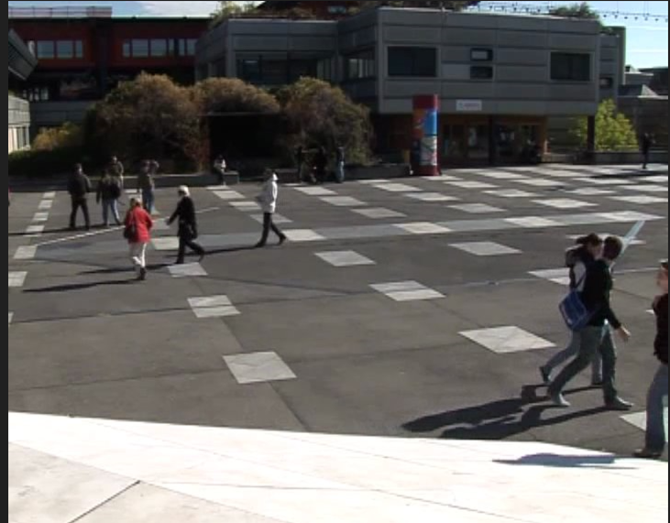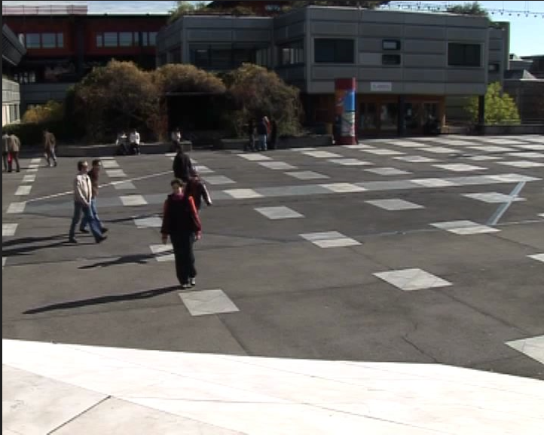

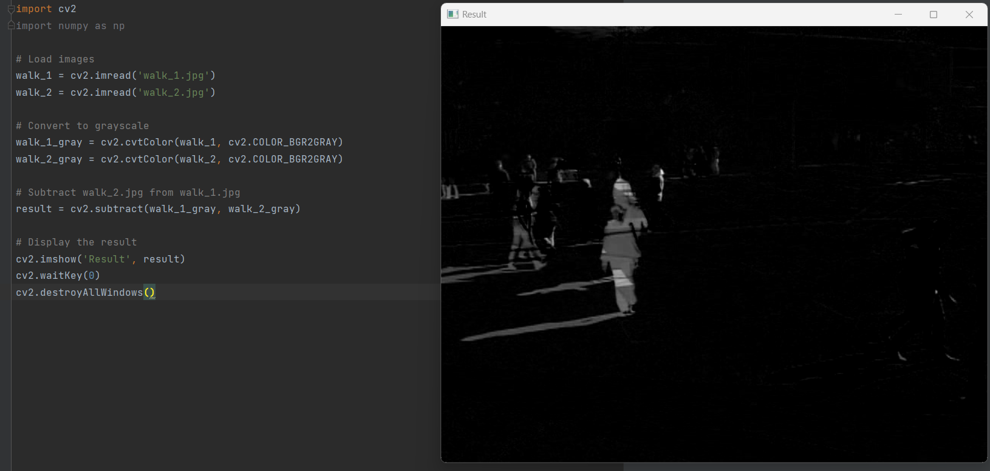

* When I subtract one image from another, I’m performing pixel-wise subtraction. The result will be a new image where each pixel value is obtained by subtracting the corresponding pixel values in the two original images.it means If two pixels have the same intensity in both images, their subtraction will result in a pixel with a value of zero. Converting an image to grayscale means that each pixel in the image is represented by a single intensity value (typically a shade of gray), rather than separate values for red, green, and blue (as in a color This process simplifies the image to its brightness data.

**Quetsion#6**

Threshold=57

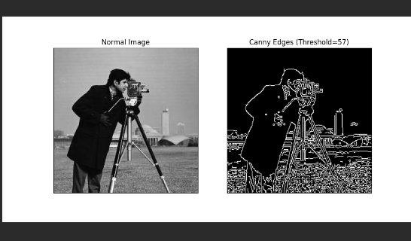

Darker regions become black: pixels are converted to black, including most of the shadows on the person, camera body, and background , Brighter regions become white: pixels become white Loss of detail: Fine details and subtle intensity variations within objects might be lost due to the binary conversion.

Threshold=107

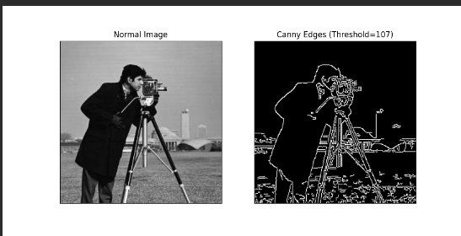

Balanced black and white distribution: More pixels fall within the threshold range, leading to a more balanced distribution of black and white areas.

Preserved details: Some details and textures within objects like skin, clothing, and camera features might be retained due to the wider threshold range.

Threshold=167

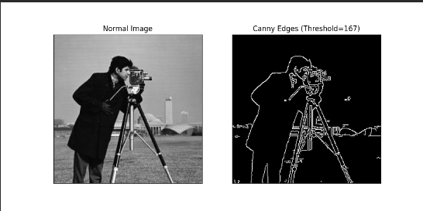

Brighter regions become black: Pixels are converted to black, now including significant portions of the person's face, body, and parts of the camera.

Limited white areas: Only the very brightest regions, like specific highlights on the camera or background, remain white.

Loss of information: Many features and details are lost due to the majority of the image becoming black.

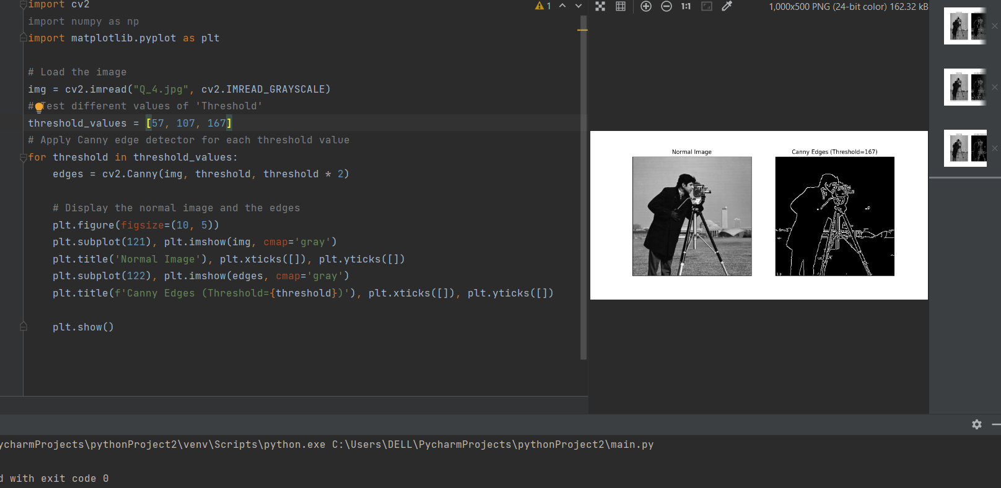

**Appendix**

**Q2.1**

import numpy as np  
import cv2  
  
def myImageFilter(input_image, conv_filter):  
 padded_image = _pad_image(input_image, conv_filter.shape)  
 output_image = np.zeros_like(padded_image)  
 for i in range(padded_image.shape[0] - conv_filter.shape[0] + 1):  
 for j in range(padded_image.shape[1] - conv_filter.shape[1] + 1):  
 patch = padded_image[i:i + conv_filter.shape[0], j:j + conv_filter.shape[1]]  
 product = patch * conv_filter  
 output_image[i, j] = np.sum(product)  
 output_image = output_image[:input_image.shape[0], :input_image.shape[1]]  
 return output_image  
  
def _pad_image(image, filter_shape):  
 pad_height = filter_shape[0] // 2  
 pad_width = filter_shape[1] // 2  
 padded_image = np.pad(image, ((pad_height, pad_height), (pad_width, pad_width)), mode='constant')  
 return padded_image  
  
def generate_gaussian_kernel(sigma):  
 kernel_size = 2 * int(sigma) + 1  
 kernel = np.zeros((kernel_size, kernel_size))  
 for i in range(kernel_size):  
 for j in range(kernel_size):  
 x = i - kernel_size // 2  
 y = j - kernel_size // 2  
 kernel[i, j] = np.exp(-(x**2 + y**2) / (2 * sigma**2))  
 kernel /= np.sum(kernel)  
 return kernel  
  
def test_filters(image_path):  
 image = cv2.imread(image_path, cv2.IMREAD_GRAYSCALE)  
 average_3x3 = np.ones((3, 3)) / 9  
 average_5x5 = np.ones((5, 5)) / 25  
 gaussian_1 = generate_gaussian_kernel(1)  
 gaussian_2 = generate_gaussian_kernel(2)  
 gaussian_3 = generate_gaussian_kernel(3)  
 sobel_horizontal = np.array([[-1, -2, -1], [0, 0, 0], [1, 2, 1]])  
 sobel_vertical = sobel_horizontal.T  
 prewitt_horizontal = np.array([[-1, 0, 1]], dtype=np.float32)  
 prewitt_vertical = prewitt_horizontal.T[:, np.newaxis]  
  
 results = {  
 "Original": image,  
 "Blurred 3x3": myImageFilter(image, average_3x3),  
 "Blurred 5x5": myImageFilter(image, average_5x5),  
 "Gaussian (σ=1)": myImageFilter(image, gaussian_1),  
 "Gaussian (σ=2)": myImageFilter(image, gaussian_2),  
 "Gaussian (σ=3)": myImageFilter(image, gaussian_3),  
 "Sobel Horizontal": myImageFilter(image, sobel_horizontal),  
 "Sobel Vertical": myImageFilter(image, sobel_vertical),  
 "Prewitt Horizontal": myImageFilter(image, prewitt_horizontal),  
 "Prewitt Vertical": myImageFilter(image, prewitt_vertical),  
 }  
  
 for title, result in results.items():  
 cv2.imshow(title, result)  
  
 cv2.waitKey(0)  
 cv2.destroyAllWindows()  
  
# Example usage  
test_filters("House1.jpg")